|  |
| --- |
|  |
| DESIGN DOCUMENT |
| By  Maya Barakova  Kalina Atanasova |

|  |
| --- |
|  |

Table of Contents

WEB APLICATION TOPIC 2

2

TARGET AUDIENCE 2

SITE MAP 3

WIREFRAMES 3

About us 4

Home 4

Login 5

Products page 5

Sale page 6

Gift page 6

Visual Design 7

# WEB APLICATION TOPIC

# 

We are going to develop a website about wristwatches.

# TARGET AUDIENCE

The age range of our target audience is mainly women in their 20s, 30s and 40s. Our visitors can be from any place in the world. Their educational background is not of importance, though they should be able to understand the English language, since the website has only English version. They can access the website through their computers or mobile devices.

# SITE MAP

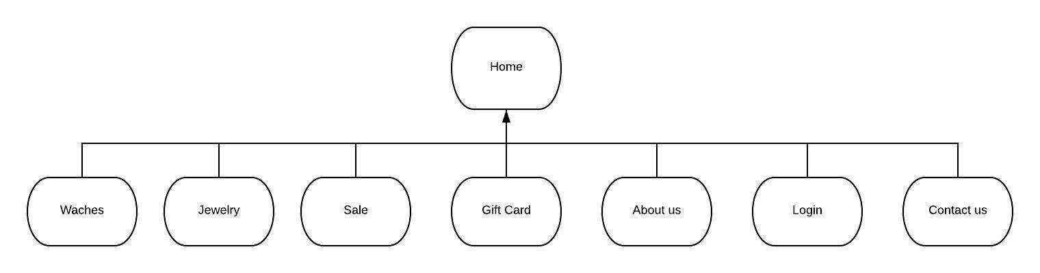

# WIREFRAMES

## 

## Home

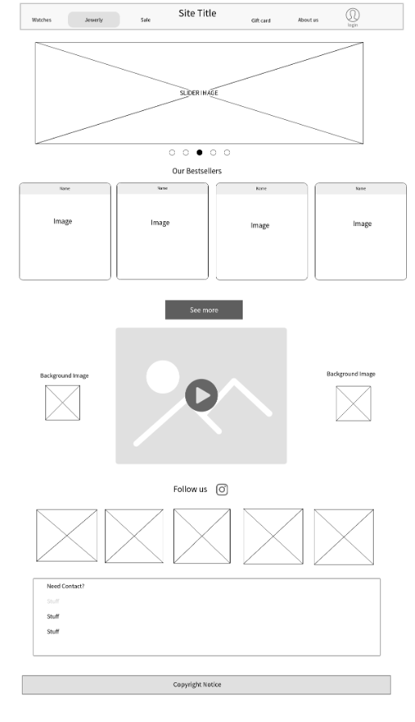

## Login

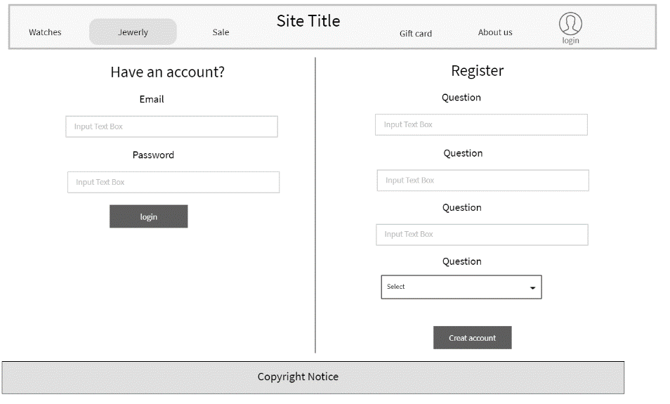

## Products page

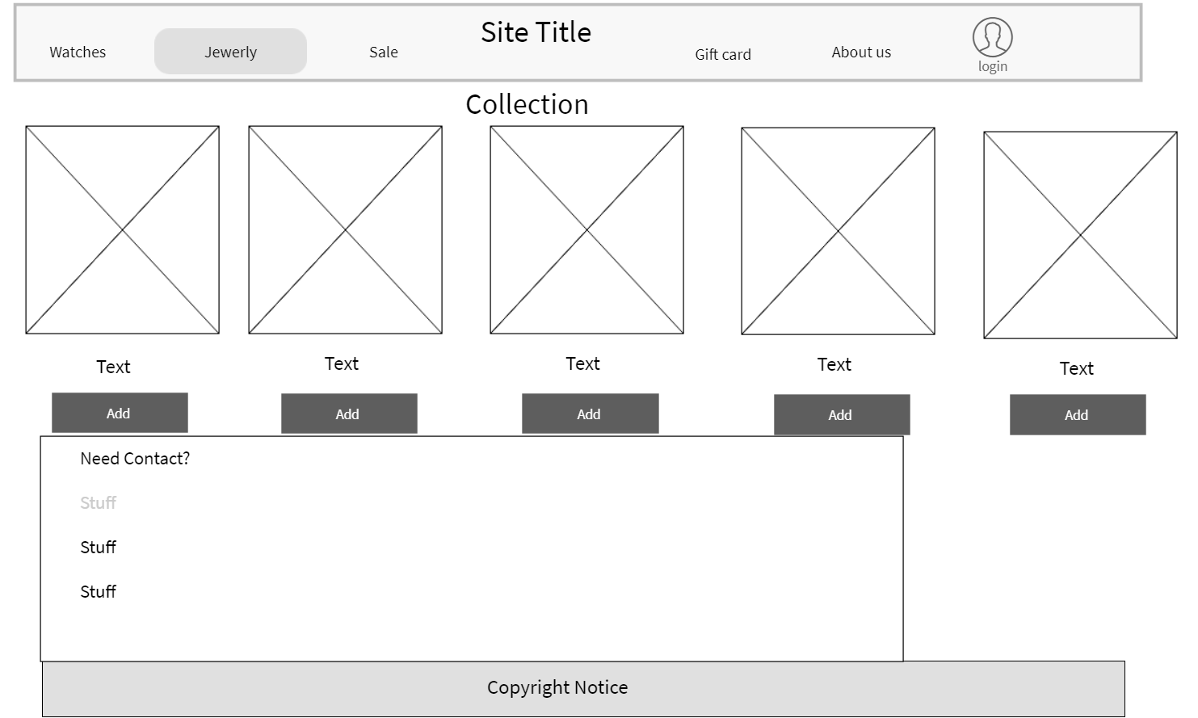

## Sale page

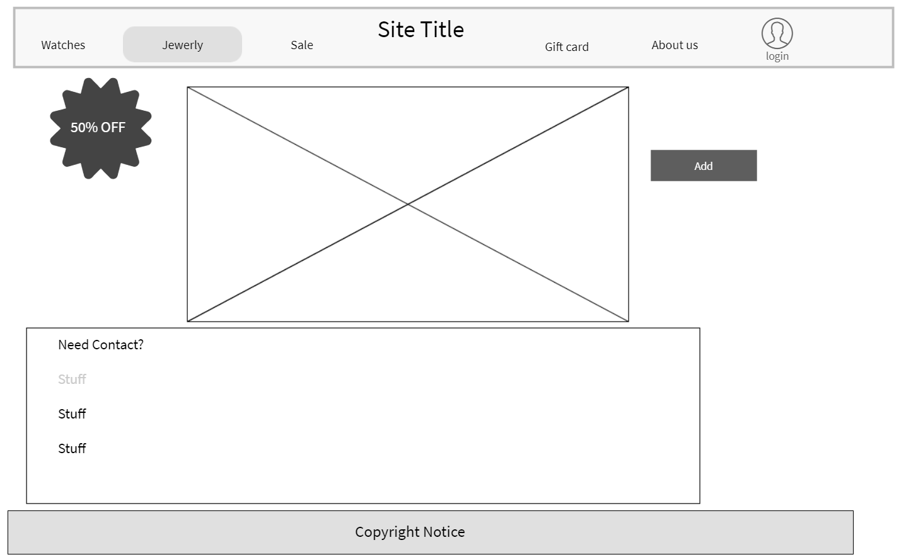

## 

## Gift page

## 

## 

## About us

## Visual Design

